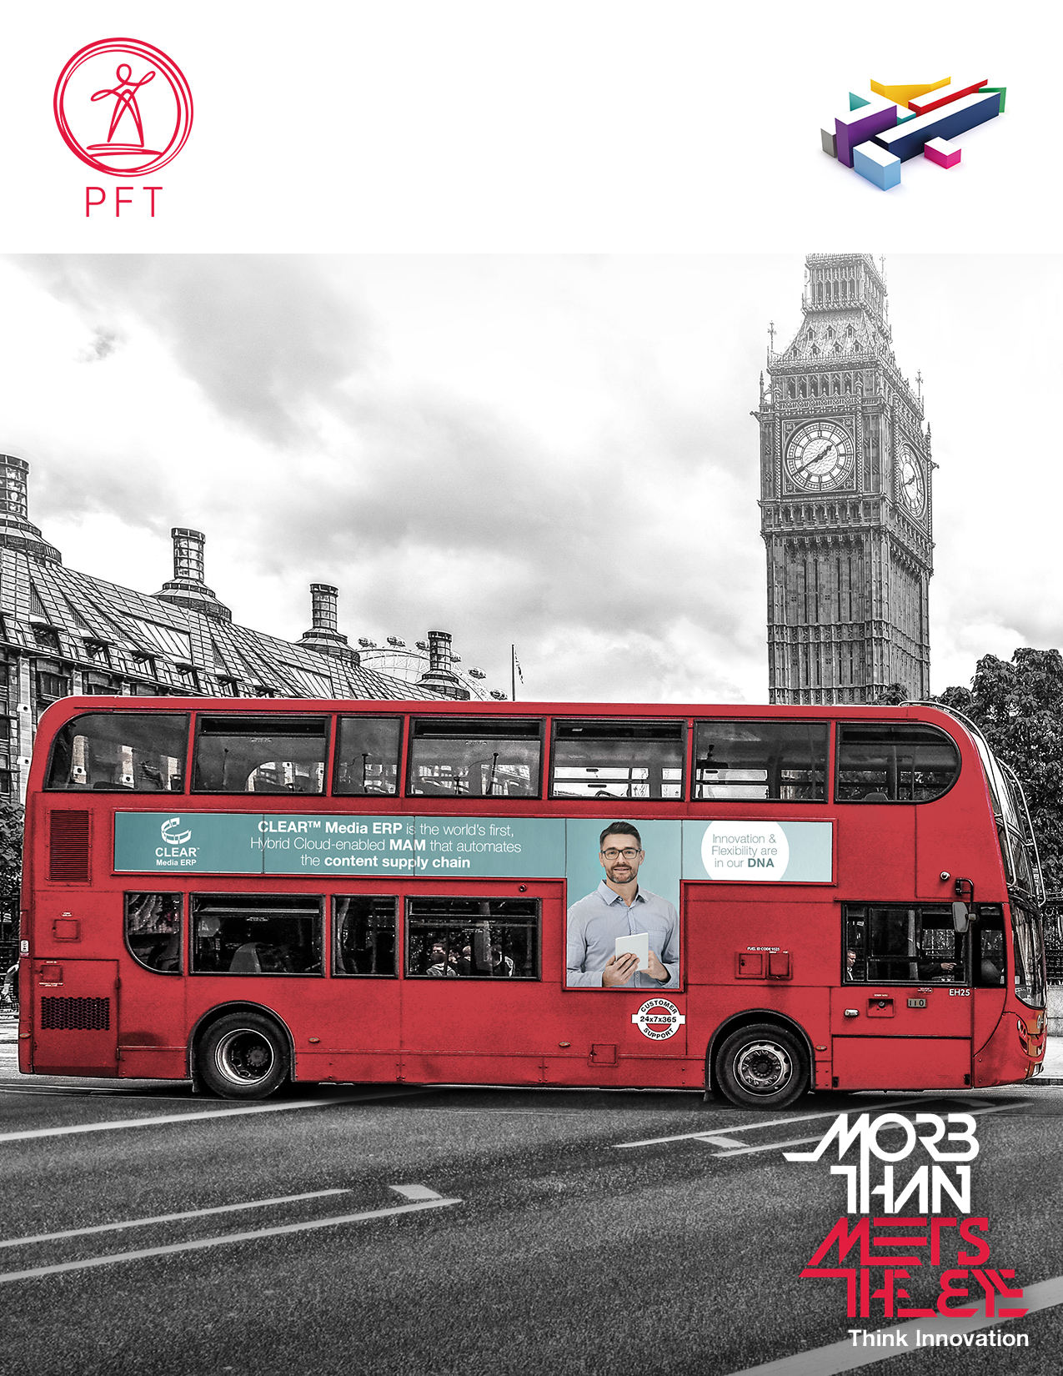

Broadcast Service Migration (BSM) Project

PFT Test Strategy V1.5

**Revision History:**

|  |  |  |  |  |
| --- | --- | --- | --- | --- |
| **Revision** | **Changes in the document** | **Author** | **Dateof change** | **Document Location** |
| Version 1.1 | Initial Draft Submitted for Approval | Atul C | 28.02.2020 | Dropbox(Channel 4 Television)\Dvořák_PrimeFocus\Testing\Test strategy |
| Version 1.2 | Incorporating Feedback from Mariola | Aditya K | 12.03.2020 | Dropbox(Channel 4 Television)\Dvořák_PrimeFocus\Testing\Test strategy |
| Version 1.3 | Incorporating Feedback from Mariola | Aditya K | 19.03.2020 | Dropbox(Channel 4 Television)\Dvořák_PrimeFocus\Testing\Test strategy |
| Version 1.4 | Incorporating Feedback from Mariola | Aditya K | 31.03.2020 | Dropbox(Channel 4 Television)\Dvořák_PrimeFocus\Testing\Test strategy |
| Version 1.4 | Incorporating Feedback from Mariola | Aditya K | 06.04.2020 | Dropbox(Channel 4 Television)\Dvořák_PrimeFocus\Testing\Test strategy |

|  |  |  |  |  |
| --- | --- | --- | --- | --- |
| **Revision** | **Date of change** | **Reviewed By** | **Approved By** | **Approval Role** |
| Version 1.1 | 28.02.2020 | Mariola | Atul C | PM |
| Version 1.2 | 12.03.2020 | Mariola | Atul C | PM |
| Version 1.3 | 19.03.2020 | Mariola | Atul C | PM |
| Version 1.4 | 31.03.2020 | Mariola | Atul C | PM |
| Version 1.5 | 06.04.2020 | Mariola, Arijit | Atul C | PM |

Table of Contents

1 Introduction 4

1.1 Background 4

1.2 Purpose 4

1.3 Objectives 4

1.4 Test Environment Landscape 5

2 Test Phases 5

3 Environment Integrations 6

4 Test Scope 6

4.1 Items out of Scope 7

5 Individual Releases Testing 7

5.1 Test Process 7

5.2 Test Environment 8

5.3 Subject of Test 9

5.4 Responsibility 9

5.5 Entry Criteria 9

5.6 Exit Criteria 10

6 System Integration & E2E Testing 10

6.1 Test Objectives 10

6.2 Test Environment 11

6.3 Subject of Test 11

6.4 Responsibility 11

6.5 Entry Criteria 12

6.6 Exit Criteria 12

7 User Acceptance Testing and Operation Readiness 12

7.1 Test Objectives 12

7.2 Test Environment 14

7.3 Subject of Test 14

7.4 Responsibility 14

7.5 Entry Criteria 15

7.6 Exit Criteria 15

8 Testing Progress Management 15

8.1 Test Recording 15

8.2 Test Reporting 16

8.3 Defect Management 16

8.3.1 Defect Resolution SLA 17

9 RACI 18

10 RAID Log 18

# Introduction

## Background

Channel 4 are implementing a new service structure and splitting their existing media preparation and distribution service lines into five separate services. These services are defined as follows:

• Media Services - Media Services Provider (MSP)

• Access Service - Access Services Provider (ASP)

• Linear playout - Linear Playout Provider (LPP)

• On-line services – On-line Services Provider (OLSP)

• Post Production and Compliance editing - Post Production Provider (PPP)

Prime Focus Technologies (PFT) has been awarded the contract for MSP and OLSP Services.

PFT will deliver the services supported by PFTs CLEARTM technology platform (MAM).

The transition of these Services is being implemented as a project.

This document covers the Test Strategy that will be followed for this project.

## Purpose

The purpose of this Test Strategy is to define the overall approach to testing and Quality Assurance guidelines that will be adhered to during the planning and execution stages of this project.

The document outlines the planned testing activities, roles and responsibilities defect management and test management to be used across the project.

Due to the fact that the solution is not finalized, the test approach to **Migration testing** (Asset, Metadata and Auxiliary files) is going to be covered in a separate document.

## Objectives

The objectives of this Test Strategy document are to ensure that: -

* The Infrastructure and Application Solution and Services are each tested to ensure the Functional, System, Non-Functional, Technical and Operational Requirements are delivered
* The necessary testing is performed throughout the project lifecycle, with minimal duplication of effort by defining what each test phase delivers
* Testing can be effectively managed and controlled
* Dependencies are recognised and addressed
* Responsibilities are set, understood and agreed by all parties who have responsibility for testing

## Test Environment Landscape

PFT will setup separate environments of CLEAR for Development, QA, Staging and Production for C4.

Build Deployment

# Test Phases

Above Diagram represents the Test Phases. The arrows in red colour represents PFTs internal testing and the arrows in blue colour represents the testing carried out in collaboration with C4 and other services providers. Unit testing, QA testing and Individual Test Phase will be repeated for each individual release.

Yellow diamonds represent Quality Gate to which we will adhere to throughout the project life cycle.

The diagram below represents the mapping of Test Phases to the Test Environment:

Note: It is advisable that separate and agreed set of environments to enable continuous development for the subsequent release.

# Environment Integrations

Below diagram represents the PFT Staging & Production environment integrations with the PIRATE BMS and other service providers.

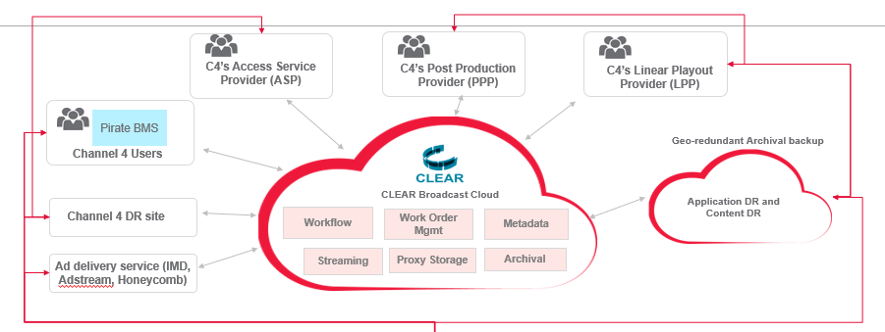

# Test Scope

The scope of testing will be in line with the BSM’s project requirements as defined in Requirements Traceability Metrics (RTM) document. The PFT’s specific requirements will cover MSP and OLSP functional, system, system integration, technical and non-functional requirements and operational readiness requirements.

All items in scope for testing and its traceability back to C4`s RTM will be managed though RTM Supersheet.

RTM`s location: Dropbox (Channel 4 Television)\Dvořák_PrimeFocus\C4 RTM SuperSheet

Any unexpected incoming signed off changed request will be managed based on the agreed Change Management Process.

## Items out of Scope

At the point of creating this document, we do not have any items of scope for this project.

# Individual Releases Testing

## Test Process

The solution being developed for MSP and OLSP is planned to be delivered across multiple releases.

Each planned Release will be documented through an agreed Release Notes document.

The Releases planned for MSP and OLSP are displayed below:

|  |
| --- |
| Release Name |
| **MSP** |
| *Ingest* |
| *R1 - Commissioned Content* |
| *R2 - C4 Eco system Ingest* |
| *R3 - Studios, Advanced Schedule* |
| *R4 - Tape Digitization* |
| *R5 - Miscellaneous (Commercials, Music, Graphics, Interstitials)* |
| *Outgest* |
| *R1 - C4 Ecosystem Outgest* |
| *R2 - CLUB , External syndicators, BOT* |
| **OLSP** |
| *Simulcast* |
| *R1: Simulcast (E2E Delivery)* |
| *R2: Simulcast (Monitoring- Orion OTT)* |
| *R3: Simulcast (DR)* |
| *Live 2 VOD* |
| *R1 - Live To VOD - Automated* |
| *R2 - Live to VOD - With Human Tasks (Not applicable with 5% solution)* |
| *VOD* |
| *R1 - OLSP Basic Design & YouTube* |
| *R2 - Non DRM Platforms* |
| *R3 - DRM Platforms* |

The objective of the Individual Release Testing phase is that the functionality tested (functional, technical requirements and small integration) are working as specified in project documentation and pass the Quality Gate Criteria.

Each Release will have a development cycle, at the end of which, an Individual Release Testing activity will be carried out to ensure that the Functional & Technical requirements have been met based on the project documentation.

The testing lifecycle, as part of the development cycle for each Release, will follow a traditional method and will be carried out prior to carrying the Individual Release Testing activities.

The method followed is described below:

1. The Development team will finish their Unit testing and will deploy their build into the QA Environment.
2. PFT QA Team will perform the System Testing in the QA Environment.
3. Post signoff by PFT QA Team, it will be deployed into the Staging Environment and handed over to PFT internal Ops for their testing.
4. Post signoff by PFT Internal Ops, the Individual Release Testing activities will be conducted in collaboration with C4 and their Partners (PPP, ASP, LSP and C4 and other external parties).

Note: This test stage will cover planned set of functional requirements and ‘small integration’ elements. The objective of the ‘small integration’ is to test that the set of components function together correctly including the workflows (the definition of ‘small integration’ is defined as all the integration parts of the same release).

1. Any issues derived from this test stage will be reviewed, fixed where necessary, re-tested in our QA environment and passed on again to C4 team for re-test and acceptance.

Note: The Individual Release Testing stage will only confirm that items in scope for testing work in isolation. The full sign off will be subject to further integration testing conducted on a complete, integrated system.

At the end of PFT QA Signoff process, we will provide a Release Note document for each planned and executed Release.

Please see below a template that will be used to communicate each Release Planned.



## Test Environment

The Testing will be carried out in Staging Environment of CLEAR which should be integrated with a designated C4’s Pirate BMS System and a designated environment of the other Third Party (ASP, PPP, LSP) Service Providers.

Test environments for Individual Release Testing of 3rd party Service Providers must be fully functional to ensure accurate `small integration` testing.  E.g. During the Individual Release Testing with Sky, the expectation is, Systems, CLEAR, PIRATE Sky integrates in real world so that tests can be correctly validated by looking up inside the Sky user interface.

In the event when a LIVE system is used for testing by other Services Providers/partners of C4, Test data must be formally agreed beforehand by C4 between all parties to ensure smooth testing.

## Subject of Test

The scope of testing will be delivered through number of planned releases. Set of relevant test scenarios (based on the Business scenarios) will be created by PFT team and peer reviewed by PFT QA team as well as being reviewed and approved by PFT Internal Ops and C4 Project Team.

As part of C4 involvement, C4 is expected to create an appropriate set of test scenarios that will be run against the Release received that would confirm the correctness of PFT`s deliverables.

## Responsibility

PFT Responsibilities:

* Requirement as part of each release are thoroughly tested with the relevant test data to provide the necessary outcome indicated in low level design
* The testing outcome will be outlined in the Release Notes document as agreed with C4
* PFTQA team will provide sufficient inputs as described in the entry criteria to enable smooth entry to this phase

Assumptions:

* C4 Team and PFTOPS team will lead the Individual Release testing phase with adequate support from PFT CLEAR QA Team.
* C4 will need to ensure that all C4 partners will be actively involved with their designated environments to ensure success of individual Release testing phase.
* C4 will also help identify SPOCs (Single Point of Contact) from each of the partners involved during the test phase.

## Entry Criteria

* The previous QA test phase completed
* All planned QA Test scenarios executed, and 100% Test coverage achieved
* Zero Severity ‘Critical’ or ‘Blocker’ Issues outstanding
* Individual Release Test Scenarios created by PFT, and by PFT and reviewed and commented by C4
* Connectivity to all designated environments of C4, Partners with CLEAR staging environment
* Individual Release testing Test Scenarios to be created by parties involved in small integration
* Test Team across C4, C4 Partners, PFTOPS and PFT CLEAR QA agreed
* Relevant test data created by all parties
* Test timeliness agreed
* Release Notes document prepared
* Demo and Trainings are provided
* Regular meetings are agreed on

## Exit Criteria

* All planned test scenarios executed, and 100% test coverage achieved
* Zero P1 (Blocker) and P2 (Critical) outstanding
* For any unresolved defects (P3&P4) impact analysis produced, reviewed and accepted. Action plan for re-coding and re-testing these defects agreed.
* RTM updated
* Test Summary report from parties involved should be produced
* Quality Gate meeting conducted with C4 team and recommendations agreed on

# System Integration & E2E Testing

## Test Objectives

The System Integration Testing is to be conducted on a complete, integrated system where the system’s or application interface crossing points with other external, internal components, services.

Recommendation is to combine SIT with E2E testingas this testing is to identify system dependencies and to ensure that the right information is passed between various system components.

The goal is to ensure that software/integrated systems work for the entire user activities involved in what the user would regard as a single business task/workflow.

The developed solution for MSP and OLSP is planned to be tested in two runs.

The aim of the first run is, to perform the full end to end testing and discover and fix any issue as they arrived. The second run will be covering complete regression to ensure that all E2E functionalities are working as expected based on the low-level design.

The testing lifecycle will follow a traditional method and will be carried after Individual Release Testing stages are completed. The method followed is described below:

1. The PFT QA team will prepare the staging environment to make sure that the code for SIT/E2E testing is deployed with including any necessary patches. SIT/E2E activities are expected to be performed by designated systems owners (C4, C4 Service Provides and C4 partners).
2. PFT QA team will perform the Sanity tests in Staging Environment to make sure that there aren’t any visible failures. Kick Off meeting would be needed to provide a Go Ahead for the testing
3. SIT/E2E will be initiated in collaboration by C4, C4 Partners, PFTOPS and other involved in this testing phase.
4. At the end of SIT/E2E Quality Gate will be conducted and mutual sign off will be expected
5. SIT/E2E Test Summary report (format to be decided) is owned and produced by C4 and by other parties who were involved in SIT/E2E.
6. Weekly Regular meeting will take place to assess the progress met

The objective of SIT/E2E testing is, to cover the overall testing on a complete system of many subsystem components or elements to evaluate the system's compliance with its specified requirement. This will be further verify/validate system's coexistence with others and tests the interface between modules of the application.

## Test Environment

The Testing will be carried out in Staging Environment of CLEAR which should be integrated with other designated environments that were specifically assigned to full System Integration testing by all C4 Partners, other Service Providers (ASP, PPP, LSP) and other external Content Providers (Sky, Virgin media etc.).

In the event a LIVE system is used for testing by other Services Providers/partners of C4, Test data must be formally agreed beforehand by C4 between all parties to ensure smooth testing.

## Subject of Test

Set of relevant SIT/E2E test scenarios will be created by PFT team.

As part of C4 involvement, C4 is expected to create an appropriate set of System Integration E2E test scenarios that will be run against the SIT/E2E runs.

## Responsibility

The responsibility of this SIT/E2E Testing belongs to all parties involved in this testing activities. The expectations are, that all involved in testing will support each other to successfully complete full System Integration testing.

It is expected that each third-Party Suppliers and C4 Partners (PPP, ASP, LSP and C4) will create their own E2E test scenarios and required test data and its quantity to test the full integration between C4 ecosystem to ensure completeness to this testing activities and most of all to reduce any unnecessary risks to testing deadlines.

It is expected that the Test Summary from each party involved in SIT/E2E testing will be created and shared across the team by C4.

## Entry Criteria

* The previous test phase completed
* All planned Individual Release Test scenarios executed, and 100% Test coverage achieved
* Zero Severity ‘Critical’ or ‘Blocker’ Issues outstanding
* Connectivity to all designated environments of C4, Partners with CLEAR staging environment
* Test Team resources across C4, C4 Partners, PFTOPS and PFT CLEAR QA agreed
* Relevant test data and its quantity created by all parties
* Test timeliness agreed
* Release Notes document prepared
* Demo and Trainings are provided
* Regular meetings are agreed on
* SIT/E2E testing Test Scenarios to be created by parties
* Other C4 partners / Suppliers who will be involved in this test phase are available
* Individual Release Testing Quality Gate conducted

## Exit Criteria

* All planned SIT/E2E test scenarios executed by all parties involved, and 100% test coverage achieved
* Zero P1 (Blocker) and P2 (Critical) outstanding
* For any unresolved defects (P3&P4) impact analysis produced, reviewed and accepted. Action plan for re-coding and re-testing these defects agreed.
* RTM updated
* Test Summary report from parties involved is produced
* Quality Gate meeting conducted with C4 team and recommendations agreed on

Note: It is expected that the Test Summary from each party involved in SIT/E2E testing will be created and shared across the team by C4

# User Acceptance Testing and Operation Readiness

## Test Objectives

This testing is to ensure that the Technology/Systems/UI/ Apps build are fit for purpose, can handle ‘day-to-day’ tasks and meets the Business, Prog., Non-Functional & Operational requirements.

The recommendation is to combine this type of testing with Operational Acceptance Testing (OAT).

This is the final test phase where Business representatives and Operational/Support Team members need to verify that the solution developed covering People, Process & Supporting Technologies meets the operational requirements and that the Operational Acceptance Criteria as specified in project documentation have been met.

This testing to be performed in Production environment in collaboration with all Service Providers (PFT, RBM), C4 Business Partners, Operational/Support Team’s representatives.

|  |  |  |  |  |  |  |  |  |  |  |  |  |  |  |
| --- | --- | --- | --- | --- | --- | --- | --- | --- | --- | --- | --- | --- | --- | --- |
| The table below outlines the UAT/Operational Test Objectives:   |  |  | | --- | --- | | **Test Area** | **Test Objectives** | | People & Organisation | Validate that people, organisation and new technology are fit for purpose. | | Operational Processes (SOPs) | To validate that the operational processes in scope (both manual and automated) are fit for purpose. | | System/Technology | To validate that all in-scope system functionality is fit for purpose. | | Interfaces | Validate all automated and semi-automated system interfaces between BSM technology and external systems are fit for purpose, technically robust and supportable | | Data | Validate the initial and ongoing data sets support operational requirements. | | System Infrastructure | Validate that the underlying system infrastructure and application software is fit for purpose, technically robust and supportable. |   The testing lifecycle will follow a traditional method and will be carried out after SIT/E2E testing activities are completed. The method followed is described below:   1. The PFT QA team will prepare the Production environment to make sure that the code for the final set (UAT/OAT) of testing is correctly deployed including any necessary patches 2. PFT QA team will perform the Sanity tests in Production Environment to make sure that there aren’t any visible failures. Kick Off meeting would be needed to provide a Go Ahead for the testing 3. UAT/OAT will be initiated in collaboration by C4, C4 Partners, PFTOPS and other involved in this testing phase. It is expected that a specific OAT Test Schedule by C4 PMs will be created so that this test phase can be conducted in a manageable way. 4. At the end of UAT/OAT Quality Gate will be conducted and mutual sign off will be expected 5. UAT/OAT Test Summary report (format to be decided) is owned and produced by C4 and by other parties involved in UAT/OAT. 6. Weekly Regular meeting will take place to assess the progress met  Test Environment The Testing will be carried out in Production Environment of CLEAR which should be integrated with other designated environments that were specifically assigned to full UAT/OAT testing by all C4 Partners, other Service Providers (ASP, PPP, LSP) and other external Content Providers (Sky, Virgin media etc.).  In the event a LIVE system is used for testing by other Services Providers/partners of C4, Test data must be formally agreed beforehand by C4 between all parties to ensure smooth testing. Subject of Test  1. All UAT/OAT business scenarios covering standard operating procedures (SOPs), operational /service rehearsals & solution readiness will be created by PFT’s team members who will be performing the required operational roles 2. All Business and Operational Support team members (from all parties involved) will be involved in executing their own business scenario’s   Operational business scenarios will be run to emulate ‘business as usual’ (BAU) or as close as possible   1. PFT OPS team will work collaboratively with other parties involved, to ensure the effective support and outcome during UAT/OAT phase.  Responsibility The responsibility of this UAT/OAT Testing belongs to all parties involved in this testing activities. The expectations are, that all involved in testing will support each other to successfully complete full User Acceptance and Operational readiness testing.  It is expected that each third-Party Suppliers and C4 Partners (PPP, ASP, LSP and C4) will also create their own UAT/OAT test scenarios, prepare required data and its quantity, and associated processes.  It is expected that the Test Summary from each party involved in UAT/OAT testing will be created and shared across the team by C4.  .   Entry Criteria  * The previous test phase completed * All planned SIT/E2ETest scenarios executed, and 100% Test coverage achieved * Zero Severity ‘Critical’ or ‘Blocker’ Issues outstanding * Connectivity to all designated environments of C4, Partners with CLEAR staging environment * Test Team resources across C4, C4 Partners, PFTOPS agreed * Relevant data (Media Files, Live feeds, Schedules, As-Runs Request Messages etc) and its quantity must be available during testing/dress rehearsal * Technology familiarisation (Training Course and User Manuals) is created and completed in time for UAT/OAT activities * Test timeliness agreed * Release Notes document prepared * Demo and Trainings are provided * Regular meetings are agreed on * SIT/E2E Quality Gate conducted  Exit Criteria  * All planned UAT/OAT test scenarios executed by all parties involved, and 100% test coverage achieved * Zero P1 (Blocker) and P2 (Critical) outstanding * For any unresolved defects (P3&P4) impact analysis produced, reviewed and accepted. Action plan for re-coding and re-testing these defects agreed. * RTM updated * Test Summary report from parties involved is produced * Quality Gate meeting conducted with All parties involved in testing and final recommendation agreed on before service change over stage |
|  |

# Testing Progress Management

## Test Recording

This is a process of logging test records, to maintain a clear audit trail and to facilitate the recording of:

* Test coverage for checking against the phase completion criteria
* Test results to check the outcome from the test execution (to compare the Expected Results and Actual Results
* Defect recording for checking deviations from expected system behaviour

Test coverage and Execution will be shared in Release Notes for Individua Release testing by PFT.

It is expected that Test Exit Report and Summary will be shared by C4 for Test coverage and Execution.

## Test Reporting

 There are specific test items that can be measured in order to give a realistic indication how the testing is progressing, for example:

* Total number of Test Scenarios created (Target 100%)
* Actual number of Test Scenarios executed (%)
* Test Scenarios outstanding (%)
* Test coverage achieved
* Progress update by Releases (MSP/OLSP)
* Defect Status

Test Report will be provided by PFTQA weekly once during the Individual release testing.

Release Notes will be provided by PFT QA team for all the Individual Release Testing and will be covering the details of testing for the release.

## Defect Management

Defect management ensures that all defects are recorded, resolved, and retested consistently, effectively and quickly. It also allows key stakeholders to accurately monitor the number, priority and status of all defects.

All defects (apparent deviations from expected system behaviour) encountered during the Test execution will be managed based on agreed defect management process.

PFT will provide Jira tool for C4 users to raise and track C4 Issues.

Defects will be tracked basis on Priority as defined below:

* Defects with P1, P2 and Qualified P3 priority - will be fixed and released in the same phase
* Defects with P3, P4 priority – P3 Will be fixed and release in subsequent phase. For P4, will be handled case to case basis and will be fixed in subsequent phases.

Defects severity are classified as below:

* Blocker (P1)- Defect would cause a single business service failure, Whole System or Product
* Critical (P2)- Defect would cause degradation to a single business service or would mean one or more business users are unable to carry out BAU work/functional area of section
* Major (P3)- Defect would degrade the service to one or more business users, but with workarounds they would be able to carry out BAU working/Feature or item
* Minor (P4) - defects have an impact on the less important data and minor functions. It can cause some malfunction but will keep the software up and running. The workaround is easy and obvious.

Defect Triage meeting will be conducted by PFT QA Manager once a week (or more frequently if necessary) and other Test Managers will be invited.

Note: Test Report format yet to be finalized

Defect reporting proposed will cover:

* Defect summary by priority/severity
* Defect by area / Release (MSP/OLSP)
* Progress update by test phase

### Defect Resolution SLA

This section is defined to find the resolution estimated time for C4 logged bugs against any individual release, SIT/E2E and UAT/OAT phase:

|  |  |
| --- | --- |
| **Internal Defects** | **SLA (in days)** |
| P1 | Will be fixed in the same phase ASAP generally 1-2 Days |
| P2 | Will be fixed in the same phase ASAP generally 1-2 Days |
| P3 | Qualified P3 Will be fixed in the same phase generally 2-3 Days |
| P4 | will be handled case to case basis and will be fixed in subsequent phases. |

Deployment of the fixes will be based on criticality of the defect and will be planned and informed to the team.

# RACI

Please find the below responsibility matrix:

|  |  |  |  |  |  |  |  |
| --- | --- | --- | --- | --- | --- | --- | --- |
| **Stage Role** | | **Test Preparation (Test Scenario Design)** | **Test Data Preparation** | **Test Execution** | **Test Reporting** | **Defect Management** | **Test Closure** |
| **Individual Release** | PFT (MSP, OLSP) | R&A | R&A | R&A | R&A | R&A | C&I |
| C4 | R&A | R&A | R&A | R&A | C&I | R&A |
| C4 Service Providers (ASP, PPP, LSP) | R&A | R&A | R&A | R&A | C&I | R&A |
| C4 Third Parties | NA | NA | C&I | C&I | C&I | C&I |
| **System Integration/E2E** | PFT (MSP, OLSP) | C&I | C&I | C&I | C&I | C&I | C&I |
| C4 | R&A | R&A | R&A | R&A | R&A | R&A |
| C4 Service Providers (ASP, PPP, LSP) | C&I | C&I | C&I | C&I | C&I | C&I |
| C4 Third Parties | C&I | C&I | C&I | C&I | C&I | C&I |
| **UAT/OAT** | PFT (MSP, OLSP) | R&A | R&A | R&A | R&A | R&A | R&A I |
| C4 | C&I | C&I | C&I | C&I | C&I | C&I |
| C4 Service Providers (ASP, PPP, LSP) | C&I | C&I | C&I | C&I | C&I | C&I |
| C4 Third Parties | C&I | C&I | C&I | C&I | C&I | C&I |

# RAID Log

Any Risks, Issues, Assumptions and Dependencies related to testing activities will be captured by PFT Program Manager and passed on to BSM Project Manager’s RAID Log document.

Our Internal RAID log document is in the below location:

Dropbox\Dvořák_PrimeFocus\Program Plan\RAID LOG

End of Document